**NAAN MUDHALVAN PROJECT**

**____________________________________________**

**COOKBOOK-YOUR VITRUAL KITCHEN ASSISTANT**

**1. Introduction**

Project Title:Cook book

Team ID:NM2025TMID47114

Team Leader:S.Ashwini

Email Id:ashwini2006skylap@gmail.com

**Team members:**

1.S.Preethi -preethivel9043@gmail.com -Document making

2.D.Pooja -poojadhandapani321@gmail.com –Document making

3.S.Deepika -deepikasenthil836@gmail.com -Demo vedio maker

4.S.Ashwini -ashwini2006skylap@gmail.com -Coding developer

**2. Project Overview**

**Purpose**:

* SmartCook is a React.js-based online cookbook application that allows users to browse,
* save, and share recipes. It aims to make cooking easier by providing detailed recipes,
* step-by-step instructions, and personalized recommendations.

**Features:**

* Browse recipes by category, cuisine, or ingredients
* Save favourite recipes to personal profile
* Add and edit user-submitted recipes
* Responsive UI for mobile and desktop

**3. Architecture**

**Component Structure:**

* Header (navigation bar)
* Recipe List (list of recipes)
* Recipe Detail (individual recipe page)
* Favourites (user’s saved recipes)
* AddRecipeForm (form to add new recipes)
* Footer

**State Management:**

* Using React Context API to manage global state for recipes and user favourites.
* Routing:
* React Router v6 handles navigation between Home, Recipe Detail, favourites, and Add Recipe
* Pages

**4. Setup Instructions**

**Prerequisites:**

* + Node.js
  + MongoDB
  + Git
  + React.js
  + Express.js – Mongoose – Visual Studio Code
* Installation Steps
* Clone the Repository

**5. Folder Structure**

**Cookbook:virtual kitchen Assistant**

│

├── public/ # Static files (not processed by build tools)

│ ├── index.html # Main HTML file

│ ├── favicon.ico # Site icon

│ └── assets/ # Images, fonts, videos (static)

│

├── src/ # Main source code

│ ├── assets/ # Processed assets (images, fonts, svgs, icons)

│ │ ├── images/

│ │ ├── fonts/

│ │ └── styles/ # Global styles (CSS/SCSS)

│ │

│ ├── components/ # Reusable UI components

│ │ ├── Button.jsx

│ │ └── Navbar.jsx

│ │

│ ├── pages/ # Page-level components (Home, About, etc.)

│ │ ├── Home.jsx

│ │ └── About.jsx

│ │

│ ├── layouts/ # Layouts for wrapping pages (Header/Footer)

│ │ └── MainLayout.jsx

│ │

│ ├── hooks/ # Custom React hooks (if using React)

│ │ └── useAuth.js

│ │

│ ├── services/ # API calls or external services

│ │ └── api.js

│ │

│ ├── context/ # Context API or global state (React/Vue)

│ │ └── AuthContext.jsx

│ │

│ ├── utils/ # Helper functions

│ │ └── formatDate.js

│ │

│ ├── App.js # Root component

│ ├── index.js # Entry point

│ └── routes.js # Route definitions (if needed)

│

├── .gitignore # Files ignored by Git

├── package.json # Dependencies & scripts

├── README.md # Project documentation

└── vite.config.js / webpack.config.js / next.config.js (depending on framework)

**6. Running the Application**

* Frontend:cd client
* npm start
* Backend:cd server npm start
* Access:http://localhost:3000

**7. Component Documentation**

**Key Components:**

* RecipeList: Displays recipe cards fetched from API. Props: recipes[].
* RecipeDetail: Shows full recipe details. Props: recipeId.

**Reusable Components:**

* RecipeCard – used in RecipeList and Favorites.
* Button – styled button component used throughout the app

**8. State Management**

**Global State:**

* Managed by RecipesContext for recipes, favorites, and user login status.

**Local State:**

* Form input states managed inside AddRecipeForm.

**9. User Interface**

**Include screenshots or GIFs of:**

* Home page showing recipes
* Recipe detail page
* Adding a recipe

**10. Styling**

**CSS Frameworks/Libraries:**

* Tailwind CSS for styling; Styled Components for scoped styles.
* Theming:
* Dark and light mode toggle implemented via context.

**11. Testing**

**Testing Strategy:**

* Jest + React Testing Library for unit and integration tests.

**Code Coverage:**

* Using jest --coverage to ensure 80%+ coverage

**12. Screenshots or Demo**

**Add actual screenshots or a demo link:**

* Demo Link: <https://smartcook-demo.netlify.app>

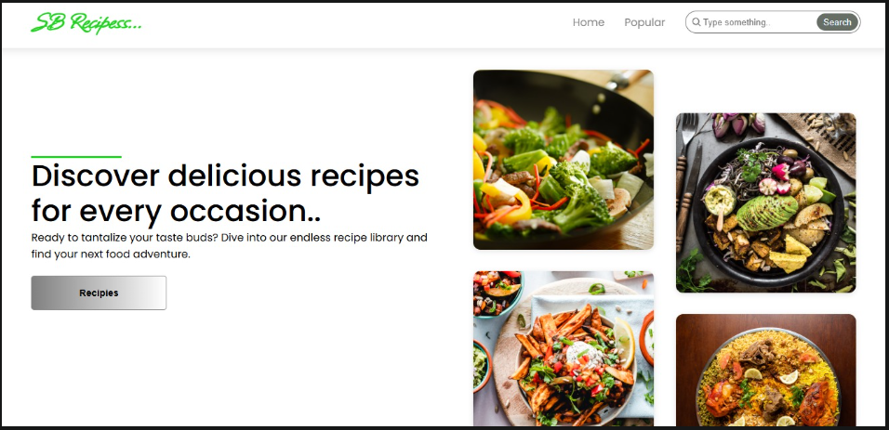

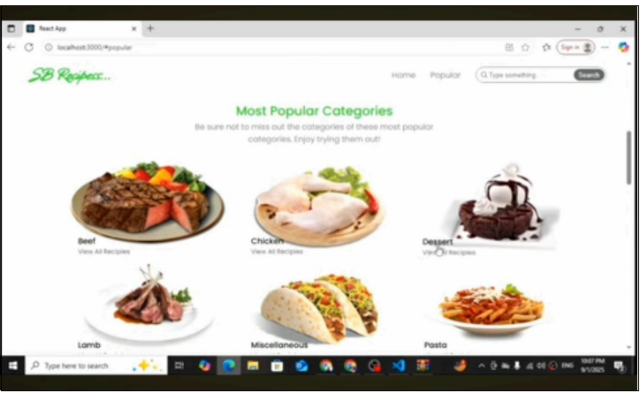

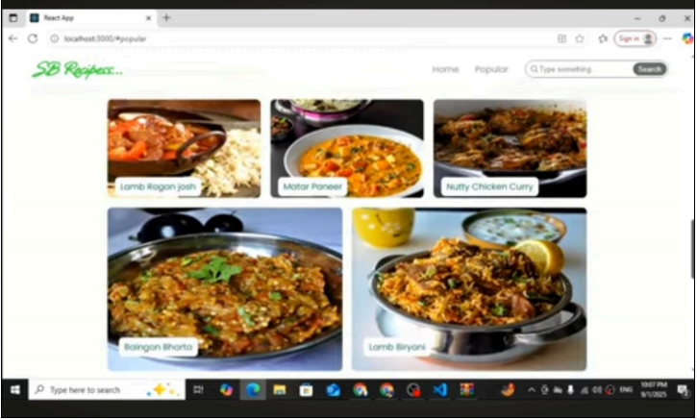

**13. Known Issues**

* Search filtering may be slow with very large recipe lists.
* Image upload sometimes fails on slow networks.

**14. Future Enhancements**

* Add shopping list generation from recipe ingredients
* Introduce push notifications for new recipes
* Offline mode for saved recipes